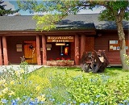
BEAVERHEAD COUNTY MUSEUM
15 S. MONTANA STREET
DILLON, MT. 59725
406 683 5027
bvhdmuseum@hotmail.com
County ID# 81-6001331

Permission and Use Form

DATE: ATTENDANT:
NAME: In Person Phone Email
PHONE # EMAIL
REQUEST DETAILS
WHO or WHAT?
WHEN? WHERE?
Please Provide Detailed Information…
SUBMITTED TO : For Follow Up

